Project 2

Milestone 1

Hiking App – Takes in some criteria, such as difficulty and length, and gives a random hike to the user. User can either choose that hike or another hike. They can click and learn more information about the selected hike, such as distance, busy-ness, map, etc.

The audience of this app is for people in the Denver/Colorado area, as those are the trails that I want to suggest in my app.

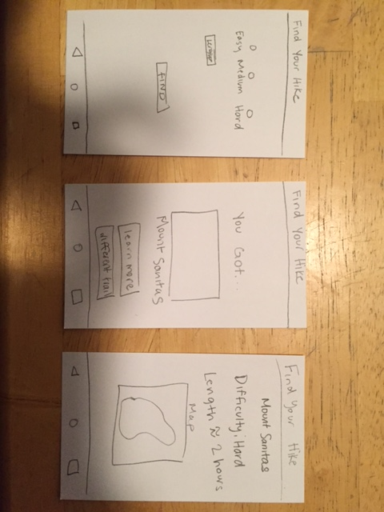There are many similar apps, such as All Trails, Let’s Hike, etc. However, I don’t really like the UI of any of those ones and they all seem to have more information than I really want.